**Digital Signal Processing (DSP) Project**  
**Course Project Overview**

**Project Outline:**

This project is designed to guide you through fundamental concepts of Digital Signal Processing (DSP), starting from basic signal representation to advanced frequency domain operations. By completing this project, you will develop a comprehensive understanding of signal processing techniques commonly used in real-world applications.

**Milestone 1: Signal Representation, Sampling, and Quantization**

**Goal:**

Understand how to create, sample, and quantize signals as the foundation for all subsequent processing.

**Tasks:**

1. **Generate and Plot Signals**:
   * **Sinusoidal Wave**: Plot continuous and discrete sinusoidal waves to understand the properties of periodic signals. This exercise helps visualize signal periodicity and amplitude characteristics.
   * **Square Wave**: Visualize a square wave, contrasting it with the sinusoidal wave. Square waves are common in digital systems and signal processing applications.
   * **Real-world Signals from Files**: Import real-world data from files and plot it. This practice involves handling external data sources and helps understand how real-world signals are processed in DSP.
   * **Custom Equations**: Generate and plot a custom signal based on a given mathematical equation. This exercise allows you to manipulate and observe different signal behaviors. (NOT GENERATED ☹)
2. **Sampling**:
   * Apply a specified sampling rate to continuous signals and plot both the original continuous signal and the sampled version. This will illustrate the concept of aliasing and demonstrate how sampling affects the preservation of signal characteristics.
3. **Quantization**:
   * Quantize your sampled signals using a set number of quantization levels. Plot the quantized signals to explore how reducing the resolution affects signal accuracy, introducing the concept of quantization noise.

**Outcome:** At the end of Milestone 1, you will have a set of signals ready for enhancement and noise reduction in Milestone 2.

**Milestone 2: Signal Enhancement through Smoothing and Noise Reduction**

**Goal:**

Improve signal quality by reducing noise and enhancing smoothness, preparing for more complex processing.

**Tasks:**

1. **Moving Average Filter (Smoothing)**:
   * Apply a moving average filter to smooth the signals created in Milestone 1. This helps reduce high-frequency noise and fluctuations, preparing the signal for further processing.
2. **Noise Reduction**:
   * Experiment with different noise reduction techniques, such as low-pass filters, to produce cleaner signals. The goal is to remove unwanted noise from the signal, enhancing its quality and making it suitable for subsequent processing steps.
   * 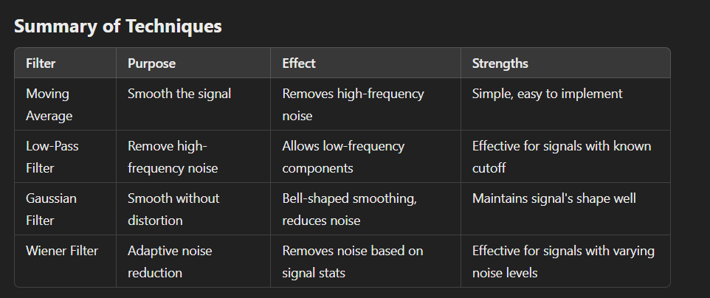

**Outcome:** The enhanced signals from this milestone will serve as input for convolution and correlation in Milestone 3.

**Milestone 3: Signal Manipulation with Convolution and Correlation**

**Goal:**

Learn how to combine and compare signals using convolution and correlation.

**Tasks:**

1. **Convolution**:
   * Perform convolution between two signals from Milestone 2. Convolution is a fundamental operation in DSP, commonly used for filtering and combining signals. This task will help you understand how convolution modifies signals based on filter kernels.
2. **Correlation**:
   * Calculate the correlation between two signals to measure their similarity. This is crucial for applications like pattern recognition, signal matching, and time delay estimation.

**Outcome:** These combined and compared signals will allow you to explore frequency domain filtering in Milestone 4.

**Milestone 4: Frequency Domain Filtering**

**Goal:**

Understand how to shape and analyze signals by filtering in the frequency domain.

**Tasks:**

1. **Frequency Domain Filters**:

**IN PROJECT**

* + **Low Pass Filter**: Apply a low-pass filter to retain low frequencies and remove high-frequency noise. This technique is essential for noise reduction in many applications.

This filter is used to remove high-frequency noise from the signal. The cutoff frequency is set to 5 Hz.

* + **High Pass Filter**: Use a high-pass filter to retain high frequencies, which is useful for emphasizing sharp transitions in signals and removing low-frequency drift.

This filter is used to remove low-frequency components, preserving higher frequencies. The cutoff is also set to 5 Hz.

* + **Band Pass Filter**: Isolate signal components within a specific frequency range. Band-pass filters are commonly used in communication systems and other applications where certain frequency bands are of interest.

This filter allows frequencies between 3 Hz and 8 Hz to pass and attenuates frequencies outside this range.

* + **Band Reject Filter**: Apply a band-reject filter to eliminate specific frequency bands. This is often used to remove unwanted noise or interference at certain frequencies.

This filter attenuates frequencies between 3 Hz and 8 Hz, allowing frequencies outside this range to pass.

### **Conclusion:**

By completing this project, you will gain hands-on experience in fundamental DSP techniques such as signal generation, sampling, quantization, smoothing, noise reduction, and filtering. These skills will serve as the foundation for more advanced DSP operations in real-world applications such as communications, audio processing, and image analysis.